- PURPOSE / SCOPE:
  - TI Fluid Systems produces products for the automotive industry that are designated as “safety” and “regulatory” items. Our products must also meet the local government regulatory requirements in the countries where our products are used. This document defines the requirements for our suppliers relating to management and identification of S/R/F products.
This requirement also defines the requirements for escalation and notification of S/R/F issues.
  - This requirement applies to all external suppliers to TI Fluid Systems globally including the sub-supplier tier levels.
  - Suppliers to TI Fluid Systems are expected to implement Safety and Regulatory processes that support the fundamental TI Fluid Systems Global Safety and Regulatory and Critical Mandatory Requirements as defined in this document.
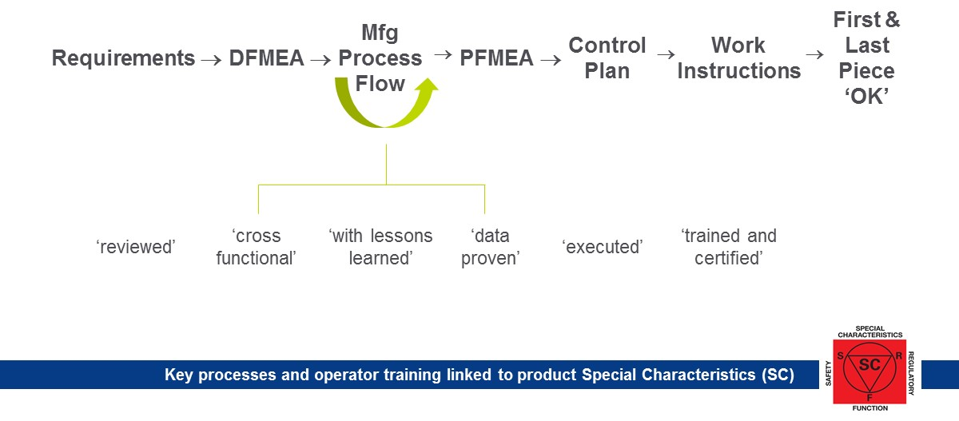
  - This work instruction will ensure important manufacturing controls are in place and adhered to which will drive the correct discipline to the manufacturing teams regarding the importance and impact of safety and critical concerns.

  - TI Fluid Systems will place the following symbols on drawings and documents to identify Special characteristics. Suppliers can use their own symbols but must provide a conversion matrix.
- RESPONSIBILITIES:
  - Document Champion: Global Director Corporate Quality Systems
  - Document Approvers: Global Corporate Purchasing Director and Global Director Corporate Quality Systems.
  - It is the responsibility of Global Purchasing Directors to ensure all suppliers to TI Fluid Systems are aware of this S/R/F document and ensure they comply with the requirements as defined.
  - It is the responsibility of Global Purchasing and Quality Directors to ensure proper escalation of all S/R/F concerns as defined in CP-4-ALL-41 Customer Safety and Regulatory Critical Concerns Procedure; either initiated by a supplier or involving a supplier.
  - It is the responsibility of Engineering to ensure that all S/R/F requirements are clearly shown on the TI Fluid Systems drawing before submission by Purchasing to the supplier.
  - Purchasing is responsible for ensuring the supplier understands the S/R/F requirements and implements a process to satisfy those requirements.
- DEFINITIONS:
  - S/R/F – Safety, Regulatory and functional designation for operational awareness of critical processing. S/R/F items are features in the design or the process that are classified as high risk for safety or mandated to meet regulatory requirements.
  - Mandatory Requirements - Important set of key manufacturing principles that are never compromised.
  - LPA - (Layered Process Audit) - S/R/F compliance is required to be linked to this document. See also CQI 8 Layered Process Audit Guidelines
  - DFMEA / PFMEA - Design/Process Failure Mode Effect Analysis – S/R/F operations are required to be linked back through the D/PFMEA’s. S/R/F operations are considered as critical and shall be severity rating as 8/10 on the PFMEA /DFMEA /internal or external specific requirements.
  - FPO - (1st Piece OK) - Defined as an outcome of a process that is compliant to all requirements including safety. The 1st PC OK is an outcome of a fully compliant process with direct alignment to the Method, Machine, Material and Man (4M).
  - PY - Poka Yoke - error proofing system applied to the process
  - C/O - Change Over (Changing from one set-up to another)
  - LPO - Last Piece OK (Inspection of last piece produced from the set-up/production run)
  - NOK - Not OK part (Product not meeting specification)
  - CPPS – Critical Process Parameter Sheet (Sheet used to document process parameters)
  - CQI-8 – Layered Process Audit Guidelines (Industry standard for LPA)

- REFERENCES / ASSOCIATED DOCUMENTS:
- CP-4-ALL-41 Customer Safety and Critical Concerns Procedure
- CP-8-ALL-41 Global Supplier Requirements Manual (GSRM)
- CW-4-ALL-410 Global Safety and Regulatory Mandatory Requirements
- CW-4-ALL-440 Special Characteristics
- IATF 16949 Automotive industry Technical Specification
- WORK INSTRUCTIONS DESCRIPTION:
TI Fluid Systems Purchasing shall communicate the requirements below to all production suppliers and ensure suppliers comply with these formal expectations. Supplier Development shall support Purchasing.
In addition, any supplier within the sourcing stages shall also be made aware of the expectation for control of S/R/F so that they understand the requirement should they become a sourced supplier.
Supplier Minimum Requirements
S/R/F Mandatory Requirements are developed to ensure critical/significant process controls have been developed, evaluated, cascaded to the entire team and effectively controlled within the manufacturing operations. Mandatory means the controls are in place before the start of production. These controls include at minimum the following activities:
- Work stations producing S/R/F product shall be uniquely identified with signage that indicates that process is used to produce S/R/F product.
- All documents related to S/R/F processes and products shall clearly identify S/R/F features. (Work instructions, FMEAs, Flow Diagrams, check lists, etc...)
- DFMEA: Shall utilize a specific and easily recognized S/R/F symbol to identify all S/R/F related design features, properly identify the risk and clearly define the severity for each risk. Shall include all items identified as Significant or Critical on the drawing and lessons learned and design input from technical reviews.
- Manufacturing Process Flow Diagram: The Process Flow Diagram shall include all steps/movements in the process for producing the product. The Process Flow Diagram shall align with the DFMEA and work stations where S/R/F features are produced shall be identified with the S/R/F symbol. The S/R/F sign will be used to clearly identify the process where the S/R/F feature is produced.

- Process Failure Modes Effects Analysis (PFMEA): Shall align with the Process Flow Diagram and utilize the S/R/F symbol to identify all S/R/F related processes are clearly identified and properly identify the risk and clearly define the severity for each risk. Shall include all items identified as S/R/F in the DFMEA, as indicated on the drawing and lessons learned and design input from technical and feasibility reviews.
- Control Plan: Shall align with the PFMEA and Process Flow Diagram and utilize the S/R/F symbol to identify the measures required for ensuring S/R/F product is properly controlled.
- Work Instructions: Shall align with Control Plans and shall utilize the S/R/F symbol to clearly identify the measures required for controlling S/R/F processes.

PRINCIPLES/R/REQUIREMENTS:
- Set-Up Verification (FPO) –
- Traceability
- Qualified Operators
- Clear Defined NOK Part Segregation
- Product/Process Specific requirements and instructions
- 100% Leak Test where required
- Reaction Plan for concerns (S/R/F History Log).
- Validation of process parameters.
- Gauge Standards.
- No Rework permitted for S/R/F processes without formal approval
- Well defined formal Escalation process
- Validation and verification of the S/R/F process

- There shall be a robust escalation and notification processes that ensures immediate escalation of S/R/F issues and immediate notification to TI Fluid Systems.
- Supplier S/R/F concerns shall be responded to using a cross functional team utilizing a formal problem solving process which includes implementation of improvement plans to reduce / eliminate those concerns and proactive measures to ensure no repeat concerns.
- All operators working on S/R/F processes shall be properly trained to perform the required work and also fully understand the application of the parts and the risks and the potential consequences of S/R/F product concerns in the field.
- Set-Up Verification (FPO): Requires 1st PC OK process at next shift, set-up or major change over or maintenance action, and 1st PC OK Criteria, including all safety criteria fully met and documented evidence of validation. 1st PC OK samples shall be dated/displayed. Variable data is required where applicable vs. check marks or attribute style designations.

- Traceability/Lot Control Back to Process/Date/Shift: Requires - tag/label/ink jet/etching or other permanent ID to be affixed to the finished part. Traceability requirements must be documented and establish robust control at the component lot level. Must be validated as part of 1st PC OK process.
- Clear Defined Not OK (NOK) Part Segregation: There shall be clearly defined locations/bins for segregating NOK parts that ensures these parts cannot be inadvertently used in production or shipped. All NOK parts shall be documented and accounted for.
- Rework or off standard processing of product with S/R/F requirements is not permitted unless the supplier has written authorization from TI Fluid Systems before the work is performed.
- Any/all changes to processes, product or materials that have S/R/F requirements shall be approved by TI Fluid Systems prior to manufacture and shipment of the product. This written approval can only be requested following the TI Fluid Systems Supplier Change Management Procedure and shall utilize the TI Fluid Systems Supplier Request for Change Approval (SRCA) form.
- Suppliers shall utilize Layered Process Audits and other internal audits as needed to ensure compliance and effectiveness of their S/R/F process and controls.
- Prior to shipment all pallets / shipping containers for S/R/F products shall be:
- Identified with the Safety, Regulatory, Function signage available on the TIFS Supplier Resource site www.tifluidsystems.com (figure 1 shown below), or
- Identified with the suppliers own symbol(s) supported by a conversion matrix.
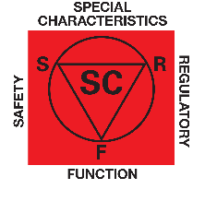

Figure 1: TIFS S/R/F Signage

- WORK INSTRUCTIONS TURTLE:
With Who?
(Competence/Skills/Training)
- Qualified Operators
- Production Supervisors / Team Leaders
- Plant Managers
- Production Managers
- Quality Managers
- Plant Engineering Managers
- Corporate Quality
- Managing Directors
- Corporate Quality
- Regional Engineering Teams

With What?
(Materials/Equipment)
- Historical Records (Check sheets)
- Tools – Checking Fixtures
- Lab Equipment
- Visual Tools – Acceptance Criteria
- Computer Systems
- Manufacturing Equipment
- Test Component

Process
S/R (Safety, Regulatory and Functional) MANDATORY REQUIREMENTS in PRODUCTION
Inputs
- Control Plan’s
- Customer Specifications
- Customer Drawings
- Assembly , subassembly and component prints
- PFMEA & DFMEA
- MCS / MES specifications
- Lessons Learned (Yokoten)
- Design Guide (DFMEA)

Outputs
- Check sheets and Records.
- Traceability Data
- Process Reaction
- Management LPA
- Visual Factory
- Alert
- Deviation
- Lessons Learned
- Updated Mfg. Standards

With What Key Criteria?
(Measurement Assessment)
- Layered Process Audit - completed to schedule (Effectiveness)
- Completion of SC definition of product release to manufacturing process control plan- Confirmed during internal audit 100% compliance (Efficiency)
- Reduce P1/P2 concerns (quarterly) Goal: Year over year improvement (Effectiveness)

How?
(Methods/Procedures/Techniques)
- Check sheets and Records
- FPO (4M)
- Training/Certification Program
- S/R/F Mandatory Rules Cards –
- S/R/F Sign in the work cell
- S/R/F Layered Process Audit Check sheets
- Approved Process Deviation
- QRQC

- REASON FOR CHANGE TABLE:

REVISION LETTER | REVISION DATE | DESCRIPTION OF CHANGE | APPROVAL HISTORY
A | 30JULY2016 | New work instruction release for external and sub supplier tier levels | Global Director Corporate Quality Systems
B | 7th March 2018 | Updated to align with IATF 16949; includes new document number, process owner and reference updates. Also added “Functional” | Global Director Corporate Quality Systems
C | 25th July 2018 | Revised 6.0 Process Turtle to include effectiveness and efficiency metrics. | Global Director Corporate Quality Systems
D | 19th February 2019 | 1.5 Added Functional and Functional Process requirement | Global Director Corporate Quality Systems
E | 21st June 2022 | TI Fluid Systems logo was TI Automotive  TI Fluid Systems was TI Automotive multiple locations  Added Clause 5.12: Prior to shipment all pallets / shipping containers for S/R/F products shall be:  - Identified with the Safety, Regulatory, Function signage available on the TIFS Supplier Resource site www.tifluidsystems.com (shown below) or,  - Identified with the suppliers own symbol(s) supported by a conversion matrix. | Director Corporate Quality Systems

